AUDIO
How to record and publish an audio clip with SoundCloud

This project has been funded with support from the European Union. This publication reflects the views only of the author, and the Commission cannot be held responsible for any use which may be made of the information contained therein.

What is SoundCloud
SoundCloud is a Swedish online audio distribution platform based in Berlin, Germany, that enables its users to upload, record, promote, and share their originally-created sounds.

How to create an account
Register in https://soundcloud.com
It allows to create an account using Google or Facebook account or sign up with email/password.

Apps
Android App - https://play.google.com/store/apps/details?id=com.soundcloud.android
iOS (Apple) App - https://itunes.apple.com/app/soundcloud/id336353151
Firefox App - https://marketplace.firefox.com/app/soundcloud

Conditions
It is free to use, with a limitation of recording up to 3 hours, beyond that there are paid subscriptions schemes.

Help links
FAQ - http://help.soundcloud.com/
Video tutorial - https://youtu.be/P7hh7lRPOdE

Profile and other features
Your account shows your dashboard with all your sound tracks. It shows who is following you, whom you wish to follow, it allows to create groups, see statistics of access to your sound tracks.
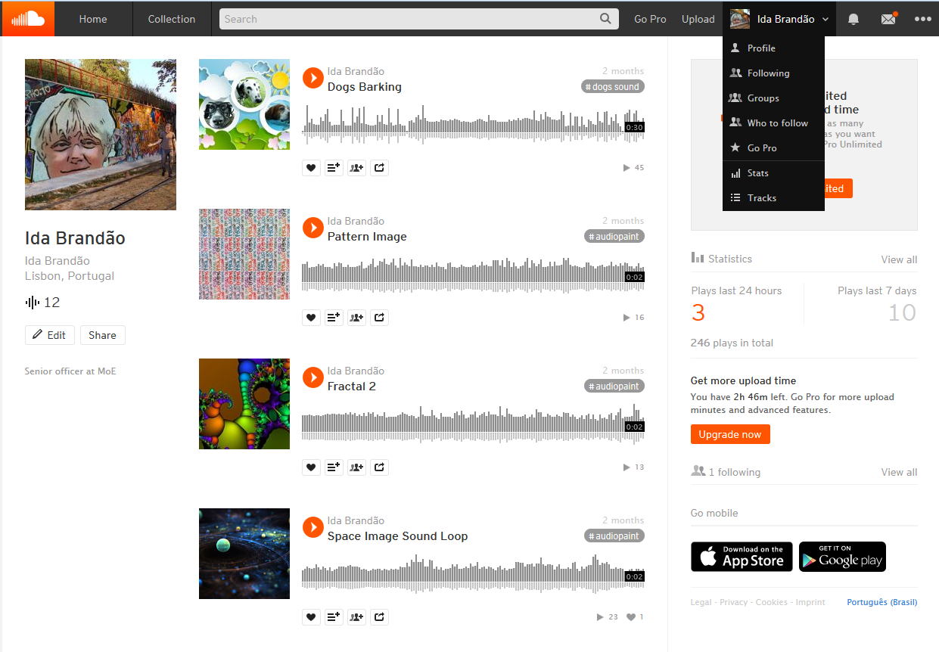
Ilustração 1-SoundCloud screen with dashboard, all tracks produced

How to upload or record
It shows a screen with the option to upload an audio file from your computer or to start a new recording
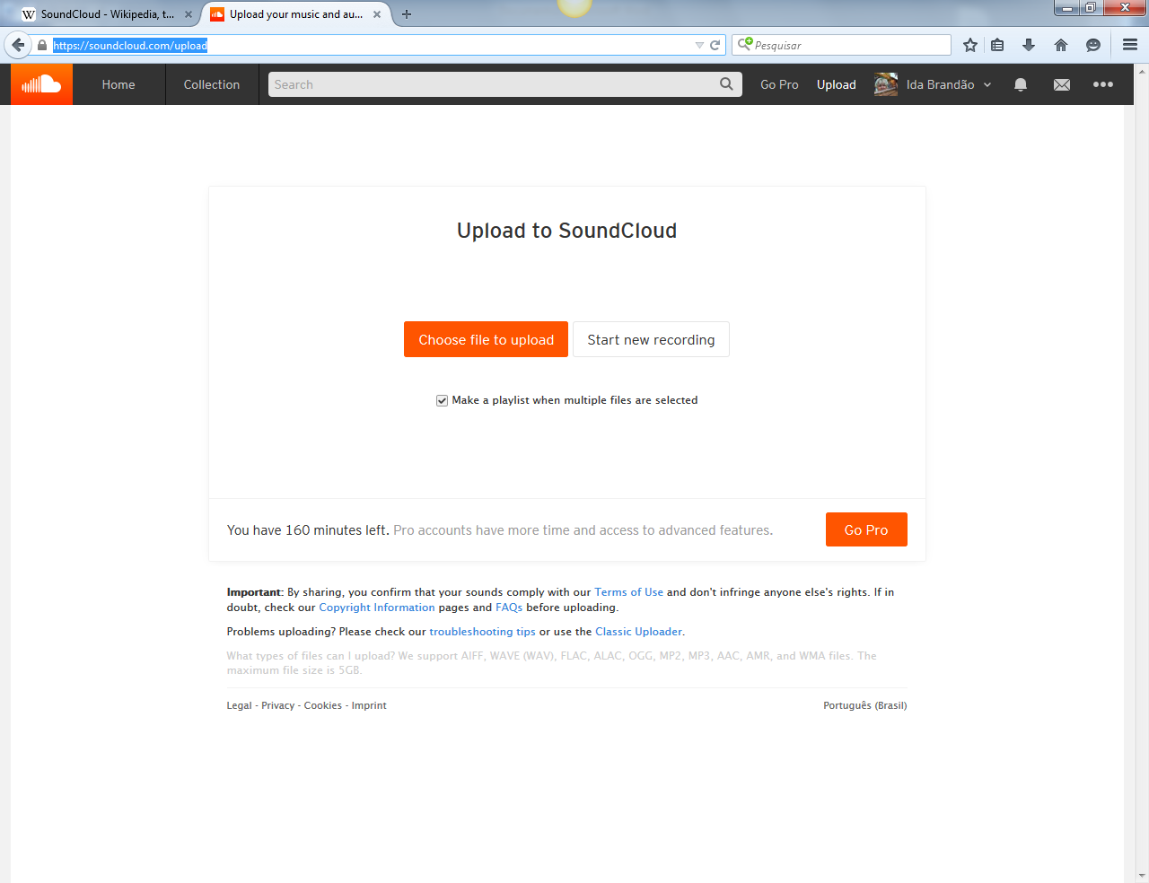
RECORD
UPLOAD
Ilustração 2-SoundCloud screen with upload and record options

Upload and Publish
Uploading a file from your computer, it shows some fields to write a title of the audio clip, tags, a description. You can upload an image related to the audio file, so that it may be easier to identify it. It shows options to make it private or public. After the upload is complete, you have to click on the save button, at the bottom.
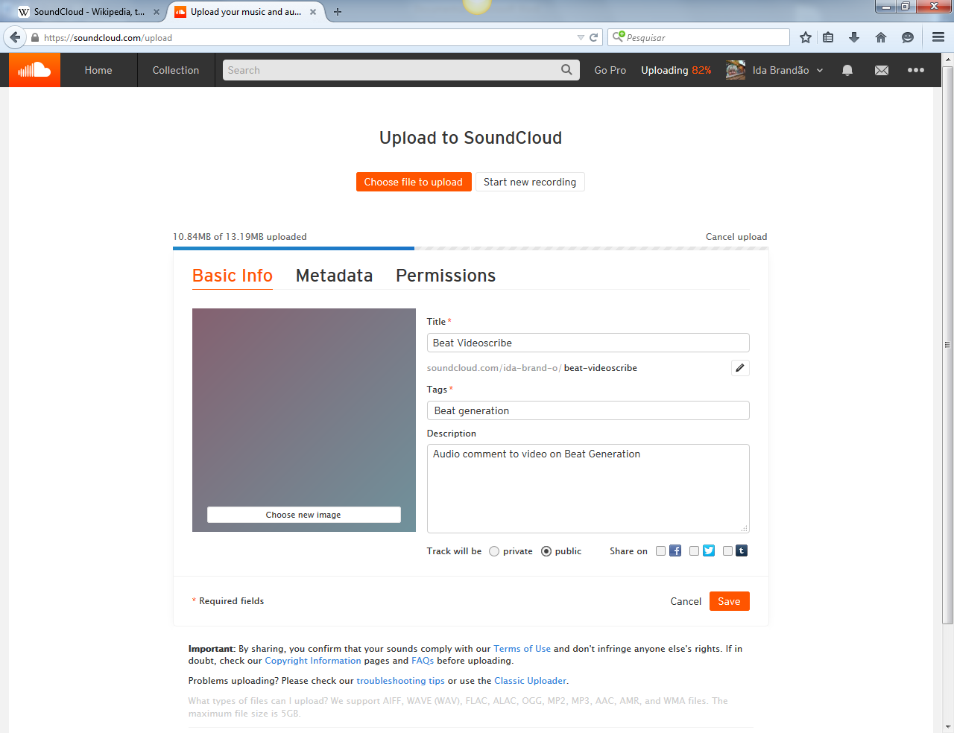
SAVE
INSERT IMAGE
UPLOAD FILE
Ilustração 3 - SoundCloud screen with file info

Share
SoundCloud provides an URL for each audio file and it allows to share in social media, showing respective buttons (Facebook, Twitter, Google+, Pinterest).
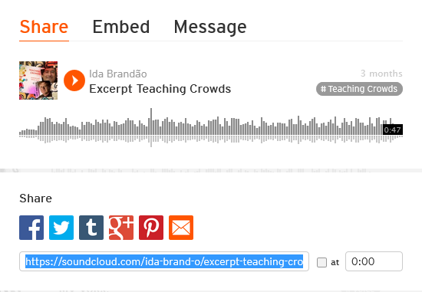
Ilustração 4 - Soundcloud screen social media share buttons
It provides code to embed in websites, namely a proper code to embed in Wordpress.
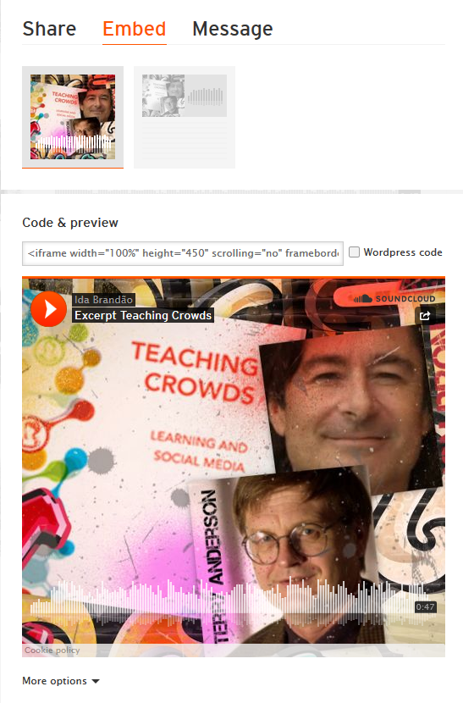
Ilustração 5 - Soundcloud screen embed code

