VIDEO
How to add subtitles or closed captions in Youtube videos

This project has been funded with support from the European Union. This publication reflects the views only of the author, and the Commission cannot be held responsible for any use which may be made of the information contained therein.

Pre conditions
Create a personal channel in Youtube – sign up for an account.
Upload a video.

HELP links
Read Google help – https://support.google.com/youtube/answer/2734796?hl=en
Explore Youtube Help Channel - https://www.youtube.com/user/youtubehelp?sub_confirmation=1
Creating Subtitles and Closed Captions (tutorial) - https://youtu.be/LCZ-cxfxzvk
OBS: Closed captions include, beyond subtitles, descriptions of who is speaking and music.

Add captions

Enter video manager
Click under video screen, the video manager menu
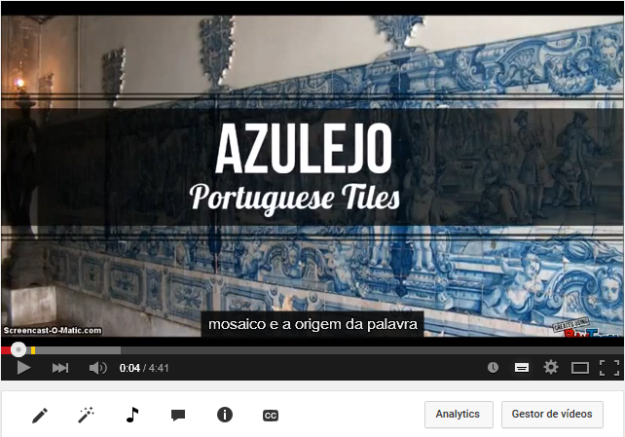
Ilustração 1 - Youtube screen video manager button
VIDEO MANAGER

Edit captions
Click the drop-down menu next to the “Edit” button for the video you’d like to add captions to

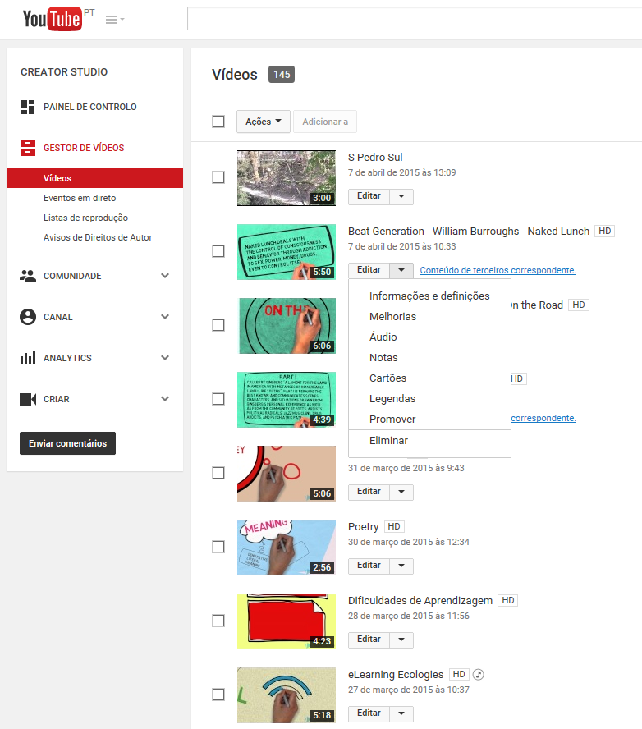
EDIT CAPTIONS
Ilustração 2 - Youtube screen edit subtitles, captions

Define/Select language
Select Subtitles and CC
Select the original language of the video from the drop-down menu (160 languages)

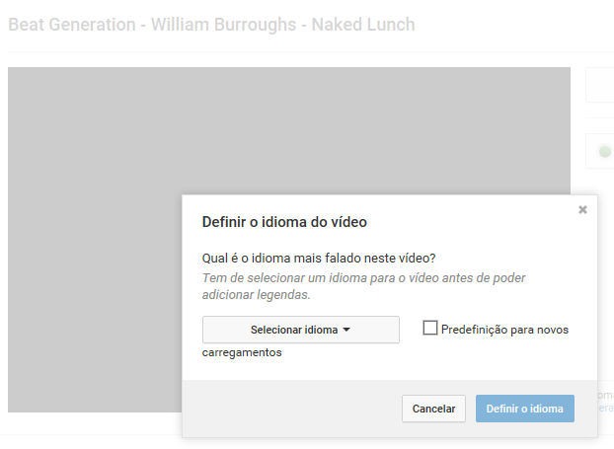
Ilustração 3 - Youtube screen define original language
SELECT LANGUAGE

ADD Captions
Click the Add subtitles or CC button
Choose the language of the subtitles or CC you would like to create
If you have already started working on that language, you will be brought directly to your draft

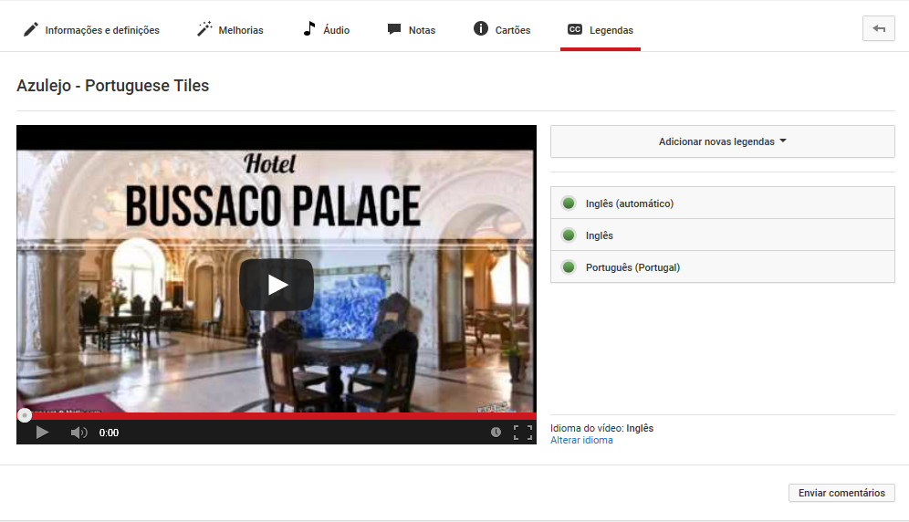
ADD CAPTIONS
Ilustração 4 - Youtube screen add captions

Write captions.
Check the timeline for synchronization.
Review at the end of introducing all captions.
Publish.

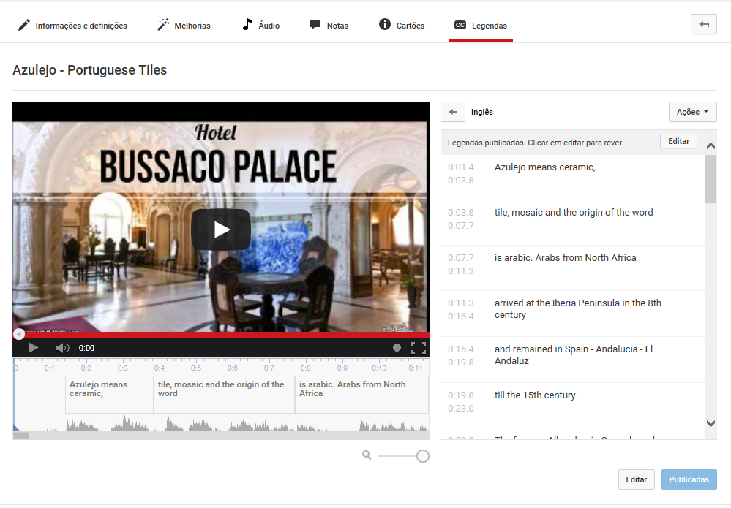
WRITE CAPTIONS
Ilustração 5 - Youtube screen write captions, publish
TIMELINE
PUBLISH

Obs: Check always for help updates, since tools evolve and new features are added.

